Ideation Phase
Define the Problem Statements

Date | 27 December 2025
Team ID | 4967
Project Name | Bookstore
Maximum Marks | 2 Marks

Customer Problem Statement Template:
To define the core problems book lovers face while searching for and buying books online, and use those insights to guide the development of Indian Bookstore.

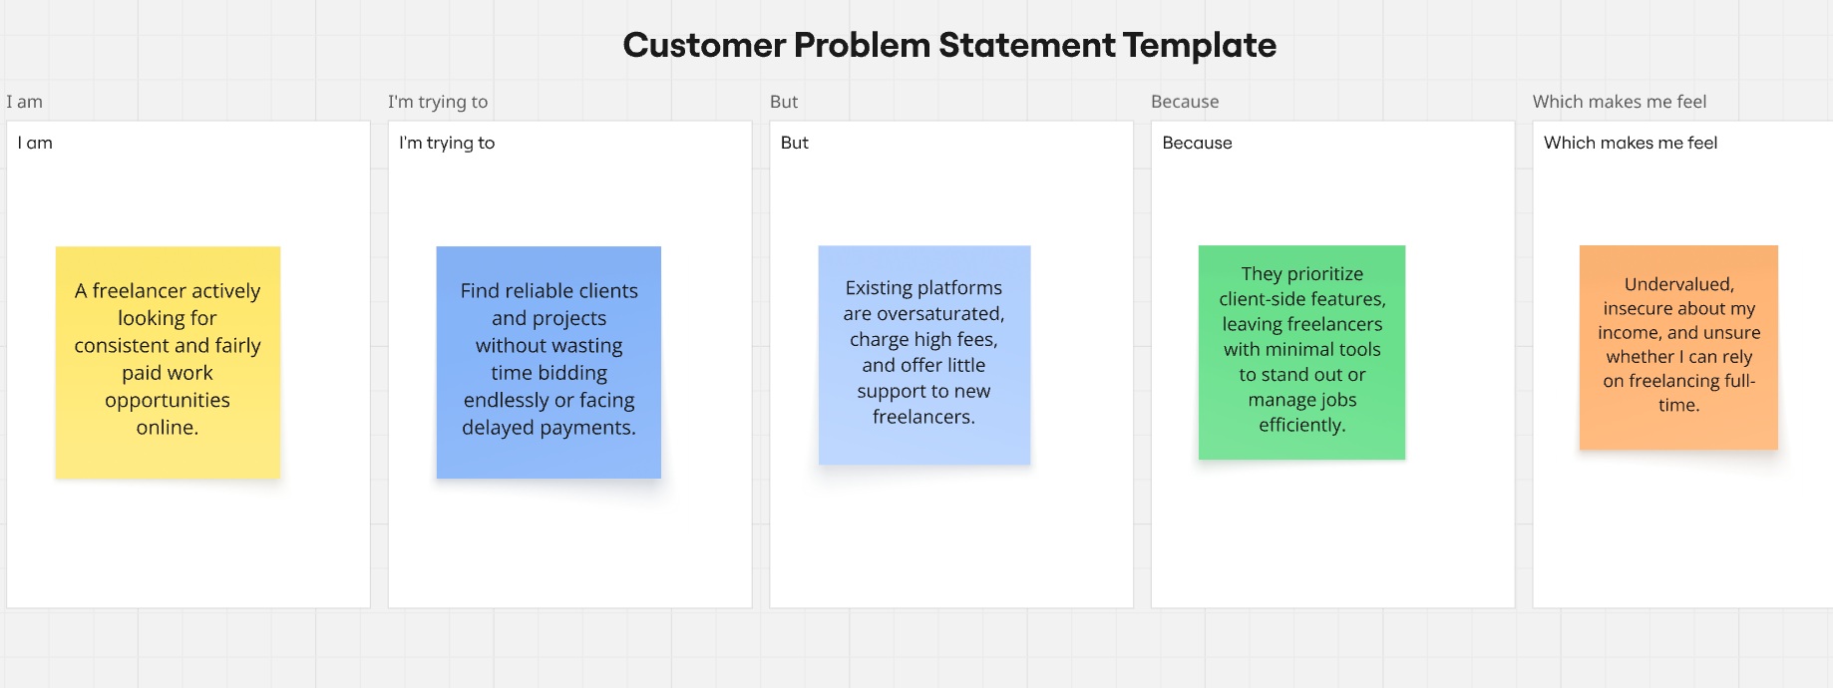
Reference: https://miro.com/templates/customer-problem-statement/

Problem Statement (PS) | I am (Customer) | I’m trying to | But | Because | Which makes me feel
PS-1 | a book lover in India | find classic and modern books at affordable prices in Indian Rupees (₹) | most platforms either lack good search, have poor images, or don't support ₹ pricing | it's hard to discover books quickly and trust the quality | frustrated and disappointed.
PS-2 | A student / reader | build my personal collection with wishlist and cart features | many sites lack wishlist, proper cart count, or admin management for fresh books | I lose track of books I want or miss new additions | annoyed and disorganized.

